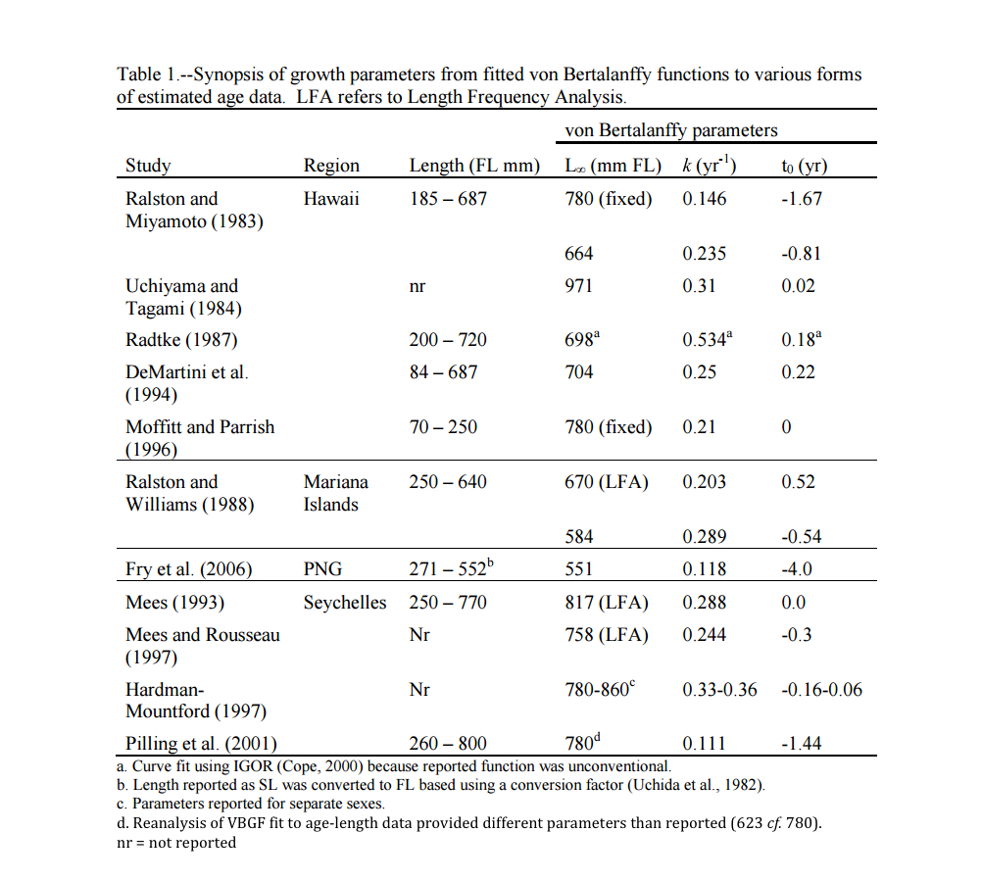

*Ralston and Miyamoto 1983*

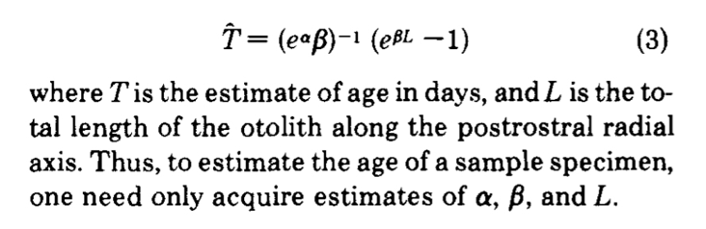In 1983, Ralston and Miyamoto used the width of otolith increment bands to model the relationship between otolith to determine a growth curve for Pristipomoides filamentosus. They performed a captive marking experiment using tetracycline to validate daily incremental deposition of otolith material in six juvenile individuals (30-34 cm FL). They also regressed the otoliths of 66 individuals against fork length and found evidence that the relationship between the growth rate of the otolith was not a simple linear relationship with somatic growth rate. Fitting log transformed otolith growth rate against otolith length for 64 individuals estimated the age of each individual using the formula to fit a 3 parameter Von Bertalanffy growth model (Ricker 1979).

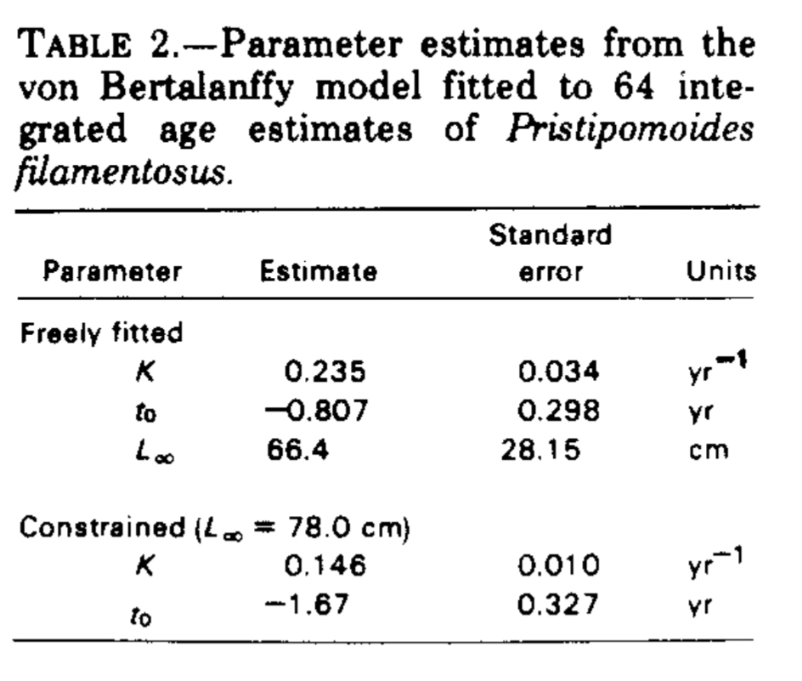Freely fitting the model resulted in unrealistically low estimates for Linf, with an estimate of maximum length (Linf) exceeded by a number of fish that had been measured in a related study. They therefore proceeded to refit the model, constraining Linf to the largest fish observed (78 cm FL).

Finally, they compared length-frequency distributions from P. filamentosus sampled at approximately the same location in French Frigate Shoals over three periods during the months of October 1979, May 1980, and November 1980. In each sample, there was a noticeable peak in number of small fish sampled that they assumed to represent a single cohort of juveniles tracked though time. They used this data to estimate size-specific growth rates as a function of time sampled using a modal class progression analysis. Using this method, they determined that growth rate was non-hemogenous and varied based on period. Rate estimates ranged between 0.020 cm/d during winter months (October – May), to 0.022 cm/d during summer months (May – November) and averaged 0.021 cm/d annually.

They note three implicit assumptions underplaying their aging methods. First, that it was appropriate to use their regression equation to predict otolith growth rates when microstructure was unclear. This assumes that visible differences in the structure of otolith are superficial and results from the preparation method. Second, they assumed that it is reasonable to extrapolate the growth of a mature fish based on the pattern of growth prior to maturity, while noting that following maturity, otolith deposition occurs in punctuated episodes event rather than continuous. If incorrect, they note that this assumption results in growth rates of large fish that are overestimates. (Larger fish / less time = faster growth. Missing time.) Finally, they assumed that one increment forms per day in immature fish. This assumption seems reasonable in light of their tetracycline marking experiment in fish between 30 and 34 cm.

*Uchiyama and Tagami 1984*

In 1994, Uchiyama and Tagami revisited the relationship between age and length from otoliths of P. filamentosus caught in the Northwestern Hawaiian Islands. Individuals were aged using annual growth increments on otoliths. They estimated von Bertalanffy growth parameters (Linf = 97.1 cm, k = 0.31, t0 = 0.02 yr) and plotted the resulting growth curve against the results of other species in the bottomfish complex.

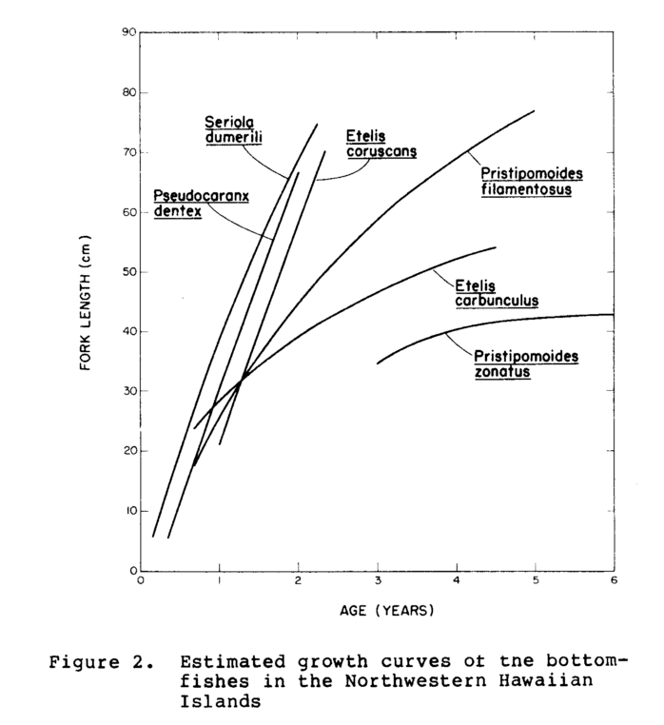

Rather than using daily increments, which became hard after the fish had reached 3 years of age, they used otolith annuli, annual growth bands they determined were formed annually in early summer. They validated this method by back calculating the length at age for the annuli to the von Bertalanffy growth curve a process which seems recursive at best.

*Radtke 1987*

In 1987 Radtke noted that the sagitta otolith of *P. filamentosus* contained four cores and as a result, the plane on which an otolith was sectioned could produce varying micro-increment counts, and thus, age estimates. Microincrements in the lapillus otolith were used to validate age estimates and it was determined that the medial cross sectional plane produced the most accurate estimates. Radtke noted the weight and fork length of specimens collected from French Frigate Shoals in the Northwesern Hawaiian Islands, and from the local fish market before removing and mounting all otoliths. Using scanning electron microscopy, daily growth increments were counted and used for age-length analysis. Radtke an unconventional function for reporting his findings, but in 2011, Andrews used Radtke’s data to produce length-at-age parameters for a von Bertalanffy fit. This resulted an Linf parameter of 69.8 cm, t0 of 0.18 (years) and the largest growth rate (K) estimated for the species, 0.534 year^-1, double many of the other estimates for the species.

*DeMartini et al. 1994*

With the availability of juvenile specimines, Demartini et al. used sagitta otoliths to estimate the age of 35 juvenile fish as well as the 57 subadult (< 20 cm FL) and adult fish used by Ralston and Miyamoto in their growth estimates. Fork length and estimated age of all 92 fish were combined to fit a revised growth curve with parameters Linf = 70.4, k = 0.25, and t0 = -0.22. Inclusion of smaller individuals improved the error associated with the fit, but larger variance in age estimates for larger individuals continued to be problematic.

*Moffit and Parrish 1996*

Using the frequency distribution of 1047 juvenile individuals caught over a 17-month period in Kaneohe bay at ranging between 60 and 100 m. Individuals ranged between 8 and 25 cm FL and belonged to one of two year class cohorts. Moffit and Parrish employed Electronic Length Frequency Analysis (ELEFAN), to fit growth parameters to length frequency distributions of fish caught each month. To run this analysis, Linf was restricted to a fixed value of 78 cm, the value from Ralston and Miyamoto’s restricted model. This analysis produced a growth parameter, K, of 0.21 y^-1. ELEFAN methods do not produce a reliable estimate for t0 and thus for Moffit and Parrish’s model, t0 is assumed to be zero.

Andrews et al. 2012

Used a Bayesian heirachical approach to modeling VBGF. Utilizing age-length data from Ralston and Miyamoto 1983 (n = 65), DeMartini et al. 1994 (n = 35) and length at age data from their own study to construct a dataset of 136 samples with lengths ranging from 8.4- 76.8 cm and aged between 0.35 – 46 years. This produced a VBGF fit with parameter estimates Linf = 67.5 cm, K = 0.242, and t0 = -0.29.

In 1983 Ralston and Miyamoto used the width of otolith increment bands to model the relationship between otolith to determine a growth curve for Pristipomoides filamentosus. They performed a captive marking experiment using tetracycline to validate daily incremental deposition of otolith material in six juvenile fish (30-34 cm FL). They also regressed the otoliths of 66 other individuals against fork length and found evidence that the relationship between the growth rate of the otolith was not a simple linear relationship with somatic growth rate. Fitting log transformed otolith growth rate against otolith length for 64 individuals estimated the age of each individual using the formula to fit a 3 parameter Von Bertalanffy growth model (Ricker 1979). Freely fitting the model resulted in unrealistically low estimates for Linf, with an estimate of maximum length (Linf) exceeded by a number of fish that had been measured in a related study. They therefore proceeded to refit the model, constraining Linf to the largest fish observed (78 cm FL). Finally, they compared length-frequency distributions from P. filamentosus sampled at approximately the same location in French Frigate Shoals over three periods during the months of October 1979, May 1980, and November 1980. In each sample, there was a noticeable peak in number of small fish sampled that they assumed to represent a single cohort of juveniles tracked though time. They used this data to estimate size-specific growth rates as a function of time sampled. Using this method, they determined that growth rate was non-hemogenous and varied based on period. Rate estimates ranged between 0.020 cm/d during winter months (October – May), to 0.022 cm/d during summer months (May – November) and averaged 0.021 cm/d annually. Further, they concluded that for mature individuals, increment deposition of otolith material is episodic rather than continuous.

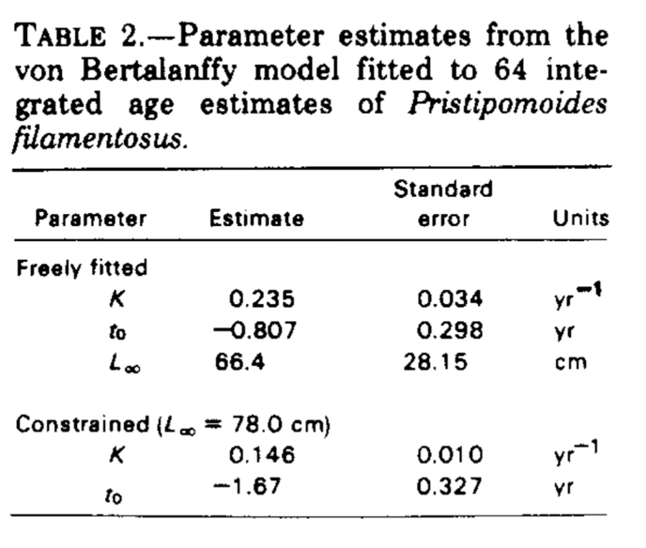 They note three implicit assumptions underplaying their aging methods. First, that it was appropriate to use their regression equation to predict otolith growth rates when microstructure was unclear. This assumes that visible differences in the structure of otolith are superficial and results from the preparation method. Second, they assumed that it is reasonable to extrapolate the growth of a mature fish based on the pattern of growth prior to maturity, while noting that following maturity, otolith deposition is a punctuated event rather than continuous. If incorrect, they note that this assumption results in growth rates of large fish that are overestimates. (Larger fish / less time = faster growth. Missing time.) Finally, they assumed that one increment forms per day in immature fish. This assumption seems reasonable in light of their tetracycline marking experiment in fish between 30 and 34 cm, but it is now believed that, particularly for fish over three years of age, deposition of otolith material is episodic rather than continuous.





In 1994, Uchiyama and Tagami revisited the relationship between age and length from otoliths of *P. filamentosus* caught in the Northwestern Hawaiian Islands. Individuals were aged using annual growth increments on otoliths. They estimated von Bertalanffy growth parameters (Linf = 97.1 cm, k = 0.31, t0 = 0.02 yr) and plotted the resulting growth curve against the results of other species in the bottomfish complex.



Rather than using daily increments, which became hard after the fish had reached 3 years of age, they used otolith annuli, annual growth bands they determined were formed annually in early summer. They validated this method by back calculating the length at age for the annuli to the von Bertalanffy growth curve a process which seems recursive at best.

In 1987 Radtke noted that the sagitta otolith of *P. filamentosus* contained four cores and as a result, the plane on which an otolith was sectioned could produce varying micro-increment counts, and thus, age estimates. Microincrements in the lapillus otolith were used to validate age estimates and it was determined that the medial cross sectional plane produced the most accurate estimates. Radtke noted the weight and fork length of specimens collected from French Frigate Shoals in the Northwesern Hawaiian Islands, and from the local fish market before removing and mounting all otoliths. Using scanning electron microscopy, daily growth increments were counted and used for age-length analysis. Radtke an unconventional function for reporting his findings, but in 2011, Andrews used Radtke’s data to produce length-at-age parameters for a von Bertalanffy fit. This resulted an Linf parameter of 69.8 cm, t0 of 0.18 (years) and the largest growth rate (K) estimated for the species, 0.534 year^-1, double many of the other estimates for the species.

With the availability of juvenile specimines, in 1994 Demartini et al. used sagitta otoliths to estimate the age of 35 juvenile fish as well as the 57 subadult (< 20 cm FL) and adult fish used by Ralston and Miyamoto in their growth estimates. Fork length and estimated age of all 92 fish were combined to fit a revised growth curve with parameters Linf = 70.4, k = 0.25, and t0 = -0.22. Inclusion of smaller individuals improved the error associated with the fit, but larger variance in age estimates for larger individuals continued to be problematic.

Using the frequency distribution of 1,047 juvenile individuals caught over a 17-month period in Kaneohe bay at ranging between 60 and 100 m, Moffit and Parrish employed Electronic Length Frequency Analysis (ELEFAN), to fit growth parameters to length frequency distributions of fish caught each month. Individuals ranged between 8 and 25 cm FL and belonged to one of two year class cohorts. To run this analysis, Linf was restricted to a fixed value of 78 cm, the value from Ralston and Miyamoto’s restricted model. This analysis produced a growth parameter, K, of 0.21 y^-1. ELEFAN methods do not produce a reliable estimate for t0 and thus for Moffit and Parrish’s model, t0 is assumed to be zero.

Andrews et al. 2012

As part of a study using bomb radiocarbon and lead-radium dating to esimtate the maximum age of *P. filamentosus,* Andrews et al utilized a Bayesian heirachical approach to modeling VBGF. Utilizing age-length data from Ralston and Miyamoto 1983 (n = 65), DeMartini et al. 1994 (n = 35) and length at age data from their own study to construct a dataset of 136 samples with lengths ranging from 8.4- 76.8 cm and aged between 0.35 – 46 years. This produced a VBGF fit with parameter estimates Linf = 67.5 cm, K = 0.242, and t0 = -0.29. The ratio of radiochemical isotopes in otoliths to delta 14 carbon records constructed from coral records collected off Kahe Point, Kona, Hawaii and French Frigate Shoals in the Northwestern Hawaiian Islands, by Andrews et al. (2012).

With the exception of Moffit and Parrish, all attempts to fit a growth curve to *P. filamentosus* in the Hawaiian archipelago have relied on daily or yearly otolith bands. It has been noted in the previously mentioned studies and laboratory observations that *P. filamentosus* otoliths, “lack well developed, annual growth zones” (Andrews et al. 2012). Underestimation of an individual’s age will lead to overestimates in growth rate. While Moffit and Parrish’s ELFAN approach is not limited by otolith deposition, their sampling period spans just 17 months and focuses on the growth of subset populations consisting of what are assume to be young-of-the-year and one year old individuals.